How to use the BCBS IL Provider Finder:
- The Provider Finder link can be found in multiple locations throughout the BCBS IL website. www.bcbsil.com
- You do not need to log into the website www.bcbsil.com to access the Provider Finder. Simply click on the Provider Finder tab in the light green bar or use the link below:
https://public.hcsc.net/providerfinder/search.do?corpEntCd=IL1
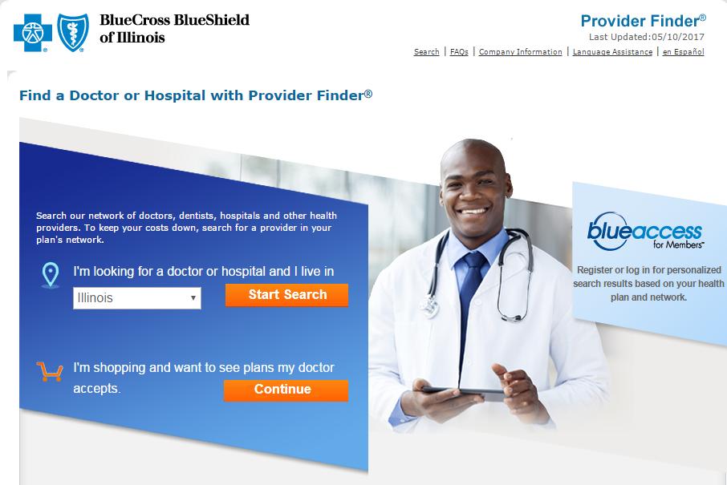
- On the home page of the provider finder, you can find other search options under, More Searches at the bottom of the page:
More Searches
- Learn more about your in-network options
- Find a provider outside of the United States
- Find a pharmacy
- Find a dentist
- Find a vision provider
- Breastfeeding Counseling

- To search for doctors and facilities, select the state and click Start Search. (Blue arrow above)
Searching Medicare Providers

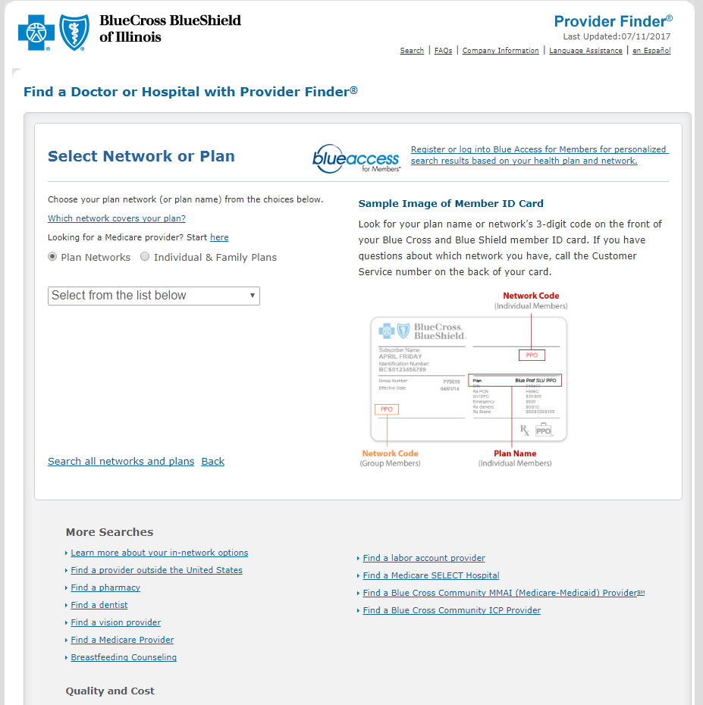

- Under the Select Network or Plan, you can also search Medicare Providers using the link by the blue arrow above.

To Search for Under 65 Providers

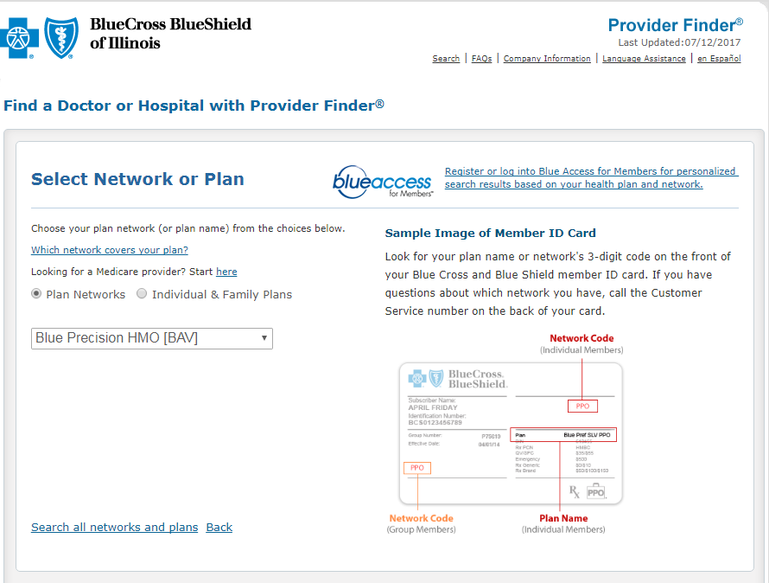

6. From the drop down (Blue Arrow), select the network you want to search.

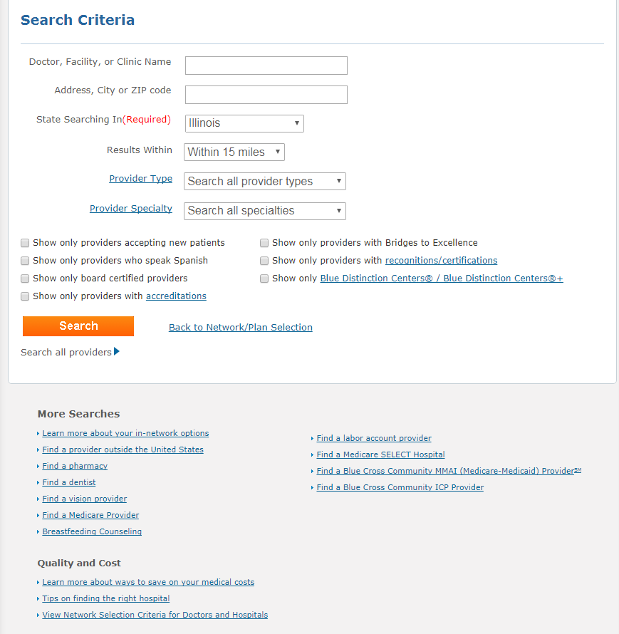
- You can search by name, zip code, provider type or specialty. After clicking Search, a list of providers will appear.

Results 1 - 50 (of 389)
Name | Specialty | Blue Star
Johnson, Alan D, MD  2500 W Higgins Rd Ste 1150  Hoffman Estates, IL 60169  (847)884-2002 | Obstetrics-Gynecology  Board Certified
Johnson, Teah M, AuD  530 NE Glen Oak Ave  Peoria, IL 61637  (309)655-2630 | Audiology
Johnson, Leslie E, MD  6339 N Big Hollow Rd  Peoria, IL 61615  (309)693-3315  Recognitions/Certification (s) | Family Practice  Board Certified

If you see no results, check the criteria entered for errors and try again. If the provider still does not show up, then that provider is not in the network searched.

PPO Providers
When you search for a provider using a PPO network in your search criteria, the physician information will only include an NPI number.

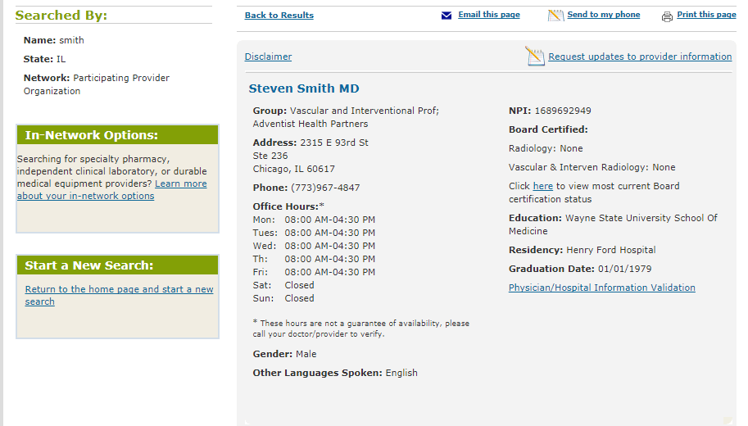

HMO Providers

When you search a provider using an HMO network in your search criteria, the physician information will include both the NPI number and a PCP number. Employees enrolling in an HMO will need to provide both the three digit Medical Group number as well as the PCP number. It is not uncommon for a physician to be affiliated with multiple Medical Groups so that is why a Medical Group number is required. Medical group example is below.

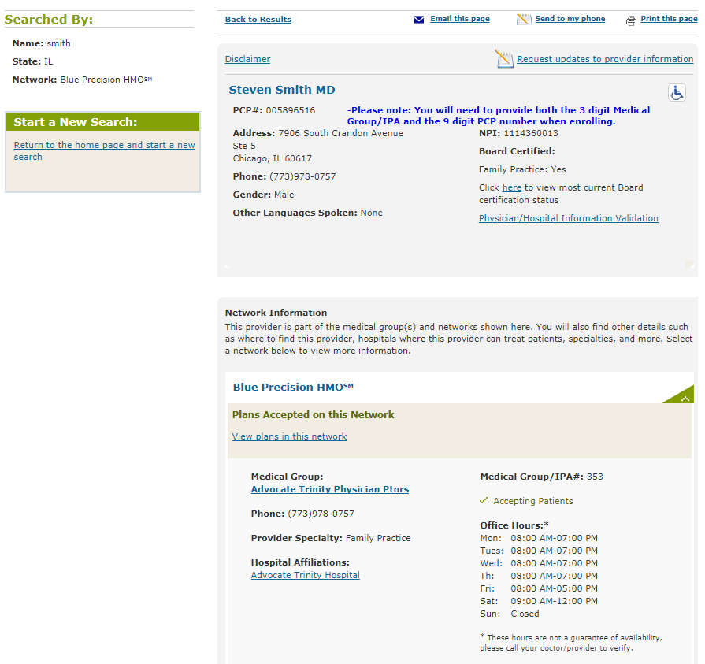

Searching Blue Options/Blue Choice Options [BCO] Network

When searching the BlueOptions/BlueChoice Options [BCO] network, be aware that this network shows providers in two tiers. To show both tiers, you need to click on “Display all in-network providers” (by the red arrow on the next page) under Narrow your results by:

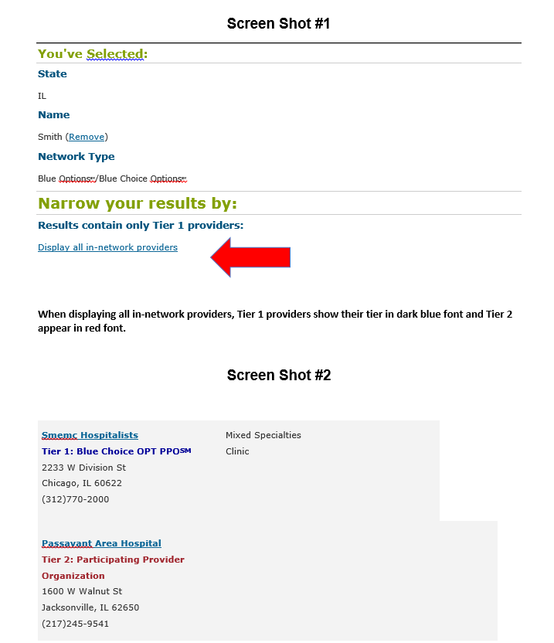

Just under the provider name, Tier 1 providers will show their tier in blue font and Tier 2 providers will show their tier in red font. Tier 1 has the richest benefits.

