Electronic Invoice Payment Instructions
Please follow the steps below to submit your electronic payment:
Step 1: Access the Payment Portal
Go to mibs.appliedpay.com.
Have your invoice available, as you will need information from it to complete the process.
Next: Complete Account Information
Enter the Invoice Number and Account Number exactly as shown on your invoice.
When prompted for the Postal Code, use the postal code listed on the invoice. This typically reflects the insured’s mailing address.
Once all required fields are completed, click Continue to Policy Information.
Select Policy Information
Under Step 2 – Policy Information, select the invoice(s) you wish to pay.
Click Continue to Payment to proceed.
Then: Choose Payment Options under Step 3
Select your preferred payment option by highlighting the appropriate box:
- Pay in Full, or Pay with Financing if Available
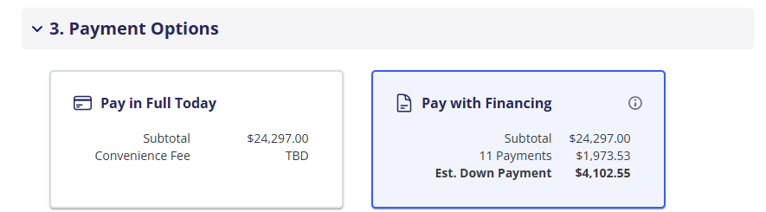
Next, choose your payment method:
- Credit Card or ACH (Electronic Check)
Please note: processing fees may vary by payment method.
Step 5: Review and Submit Payment
Carefully review all payment details for accuracy before submitting your payment.
Premium Financing (If Applicable)
If you choose premium financing, a down payment is required.
You will also be prompted to complete and submit the Premium Finance Agreement as part of the process.
Whether it’s pay in full or financing, a payment is required to request to bind coverage.

